**Tribhuvan University**

**Faculties of Humanities and Social Sciences**

**NURSERY MANAGEMENT SYSTEM**

**A PROJECT REPORT**

**Submitted to**

**Department of Computer Application**

**Ratna Rajyalaxmi Campus**

***In partial fulfillment of the requirements for Bachelors in Computer Application***

**Submitted by**

**Your Name (6-2-40-9-2020)**

**Your Name (6-2-40-15-2020)**

**September, 2023**

**Under the Supervision of**

**Supervisor Name**

**Tribhuvan University**

**Faculty of Humanities and Social Sciences**

**Ratna Rajya Laxmi Campus**

**SUPERVISOR’S RECOMMENDATION**

I hereby recommend that this project prepared under my supervision by **YOUR NAME** entitled “**NURSERY MANAGEMENT SYSTEM**” in partial fulfillment of the requirements for the degree of Bachelor of Computer Application is recommended for the final evaluation.

**______________________**

**Supervisor Name**

**SUPERVISOR**

**Department of Computer Application**

**Pradarshani Marg, Kathmandu**

**Tribhuvan University**

**Faculty of Humanities and Social Sciences**

**Ratna Rajyalaxmi Campus**

**LETTER OF APPROVAL**

This is to certify that this project prepared by “Your Name” and “Your Name” entitled **“NURSERY MANAGEMENT SYSTEM”** in partial fulfillment of the requirement for the degree of Bachelor in Computer Application has been evaluated. In our opinion it is satisfactory in the scope and quality as a project for the required degree.

|  |  |
| --- | --- |
| **Signature of Supervisor**  ---------------------------------  Supervisor Name  Lecturer, Project Supervisor  Ratna Rajyalaxmi Campus | **Signature of Coordinator**  -----------------------------------  Mr. Coordinator Name  Coordinator  Department of BCA  Ratna Rajyalaxmi Campus |
| **Signature of Internal Examiner**  --------------------------------------- | **Signature of External Examiner**  --------------------------------------- |

# 

# **ACKNOWLEDGEMENT**

The project work presented in this report has been carried out and presented at Ratna Rajya Laxmi Campus, Faculty of Humanities and Social Sciences Tribhuvan University of Technology as a part of Bachelors of Arts in Computer Application. Project is a test of not only technical skills but also team work and performance under various constraints. This journey cannot be successfully accomplished without help from experts.

Furthermore, we would like to thank our lecturers of the Department of Computer Application for their kindness in sharing their knowledge with us which in different ways has helped us in coming up with this project and being there for us when we needed them, our friends who have always been there to support us and our respondents who gave us feedbacks on improving our project work.

We will be ever grateful to our supervisor **Mr. Supervisor Name**, Lecturer without whose guidance, this project would not have become successful.

We are also grateful to our department coordinator **Mr. Coordinator Name**.

Finally, our greatest appreciation and love goes to our families, friends and mentors and for sure this would not have happened without their unconditional love, care and support.

# **ABSTRACT**

The project report titled "Nursery Management System" presents the development of an innovative web-based platform to streamline nursery operations and cater to the needs of plant enthusiasts. The system offers a comprehensive set of features, including browsing and searching for plants and gardening essentials. The report encompasses a thorough system analysis and design, outlining the functional and non-functional requirements, feasibility study, and system architecture.

The primary objectives of the Nursery Management System include enhancing nursery management efficiency, providing reliable plant care information to customers, and maintaining a user-friendly interface for both customers and administrators. The report also discusses the background study, highlighting the significance of understanding fundamental theories and concepts related to nursery management and e-commerce. A review of existing nursery management systems emphasizes the importance of a well-designed platform to streamline nursery operations and improve overall business performance.

Overall, the Nursery Management System's successful implementation demonstrates its economic feasibility and potential to revolutionize the nursery industry by providing a seamless online experience for both customers and administrators. With continuous improvements and updates, the system has the potential to further optimize nursery management practices and cater to the growing needs of plant enthusiasts in the digital age.

**TABLE OF CONTENTS**

ACKNOWLEDGEMENT i

ABSTRACT ii

LIST OF TABLES v

LIST OF FIGURES vi

LIST OF ABBREVIATION vii

CHAPTER 1: INTRODUCTION 1

1.1. Introduction 1

1.2. Problem Statement 1

1.3. Objectives 2

1.5. Report Organization 2

CHAPTER 2: BACKGROUND STUDY AND LITERATURE REVIEW 4

2.1. Background Study 4

2.2. Literature Review 4

CHAPTER 3: SYSTEM ANALYSIS AND DESIGN 6

3.1. System Analysis 6

3.1.1. Requirement Analysis 6

3.2. System Design 12

3.2.1. Architectural Design 12

3.2.2. Database Schema Design 13

3.2.3. Interface Design 14

CHAPTER 4: IMPLEMENTATION AND TESTING 20

4.1. Implementation 20

4.1.1 Tools Used 20

4.1.2 Implementation Details of Modules 21

4.2. Testing 23

4.2.1 Test Cases for Unit Testing 23

4.2.2 Test Cases for System Testing 30

CHAPTER 5: CONCLUSION AND FUTURE RECOMMENDATIONS 32

5.1 Lesson Learnt/ Outcome 32

5.2 Conclusion 32

5.3 Future Recommendations 33

REFERENCES 34

APPENDICES 35

# **LIST OF TABLES**

Table 1: Test Case of Login Form 23

Table 2: Test Case of Registration Form 25

Table 3: Test Case for User's Functions 27

Table 4: Test Case for Admin's Functions 28

Table 5: Testing Whole System 30

# **LIST OF FIGURES**

Figure 1: Use Case Diagram of Nursery Management System 6

Figure 2: Gantt Chart of Nursery Management System 8

Figure 3: E-R Diagram of Nursery Management System 9

Figure 4: Context Diagram( Level 0 DFD) of Nursery Management System 10

Figure 5: Level 1 DFD of Nursery Management System 11

Figure 6: Architectural Design of Nursery Management System 12

Figure 7: Database Schema Design of Nursery Management System 13

Figure 8: Home Page of nursery management system 14

Figure 9: Shop Page of nursery management system 14

Figure 10: Login form 15

Figure 11: Register form 15

Figure 12: Cart Page of Nursery Management System 16

Figure 13: Admin Dashboard 16

Figure 14: Admin add product form 17

Figure 15: User account page in admin page 17

Figure 16: Physical DFD of Nursery Management System 18

# **LIST OF ABBREVIATION**

CMS - Content Management System

CSS - Cascading Style Sheets

DFD - Data Flow Diagram

ER - Entity Relationship

GUI - Graphical User Interface

HTML - HyperText Markup Language

MySQL - Structured Query Language

NMS - Nursery Management System

PHP - Hypertext Preprocessor

# **CHAPTER 1: INTRODUCTION**

## **1.1. Introduction**

The Nursery Management System, a user-friendly online web based platform for all your plant-related needs. This platform offers a wide range of features that allow users to buy plants, seeds, fertilizer, pesticides and other gardening essentials, as well as access detailed descriptions of various plants and seeds.

For plant enthusiasts, this system provides a seamless browsing and searching experience, allowing them to explore a wide range of plants, seeds, fertilizers, and other gardening criteria such essentials based on various as plant type, price, and availability. Detailed descriptions, and images of plants and seeds are available to help users make informed purchasing decisions. Users can easily add items to their shopping cart, view the cart, and proceed with online purchases using secure payment methods.

Not only does this platform cater to individual users, but it also offers a seamless experience for administrators. Admins can easily add, edit, and delete products, manage product details such as descriptions, prices, and availability. User accounts can be managed, including user registration, login. Order management is made easy with the ability to view and manage orders, including order status, payment details, and order history. Additionally, website content management allows admins to update product descriptions and other relevant information [1].

With this Nursery Management System, users can explore and purchase nursery items and gardening essentials, and admins can efficiently manage their nursery operations [2].

## 

## **1.2. Problem Statement**

It is not the fact that the nursery management system already doesn’t exist. The current situation of the nursery and the nursery management system were analyzed, and the following problems were found. There is a need for an efficient and user-friendly Nursery Management System that bridges this gap by creating an online platform for purchasing and managing a wide range of plants. This system should address the challenges of plant selection, care information dissemination, and customer interaction to provide a comprehensive solution for both plant enthusiasts and nurseries.

Many people are interested in gardening and want to purchase plants, seeds, and related products. However, it is often difficult to find reliable suppliers. Traditional nurseries may not always have the desired stock of plants or may be located at a far distance from the customer. Hence, there is a need for a system that can cater to the requirements of the customers and provide them with a hassle-free experience.

## **1.3. Objectives**

The main objectives of this system are as follow:

* To simplify nursery management, the platform offers intuitive product browsing and informed selection with up-to-date plant information.
* To streamline nursery operations, the admin module enables efficient addition, editing, and deletion of product details for effective management.

**1.4. Scope and Limitation**

**Scope:**

The Nursery Management System aims to provide a user-friendly online platform for nursery owners and plant enthusiasts. It includes features such as browsing and searching for plants and gardening essentials, detailed product descriptions, secure online purchasing, order management, and administration functionalities.

**Limitation:**

The system has limitations in terms of scalability for handling a large number of users and inventory. It may not be fully optimized for mobile devices and lacks localization options. External integration capabilities may be limited, and dedicated technical support may not be available. While efforts have been made for secure payment processing, there may still be potential vulnerabilities. Customization options may be limited, requiring users to adapt to predefined features and workflows.

## **1.5. Report Organization**

The report can be organized into 5 chapters which are given below:

**Chapter 1** includes introduction includes the brief introduction of the system, statement of problem, objectives, scope and limitation.

**Chapter 2** includes background study and literature review includes the previous work related to the systems and similar works were studied and are summarized.

**Chapter 3** includes system analysis and design includes different feasibility analysis and designed system architecture, system flow diagram, dataflow diagram.

**Chapter 4** includes implementation and testing includes various implementation method and tools and also contains description of testing.

**Chapter 5** includes conclusion and future recommendations includes outcomes of the system, conclusion to the system and description about what features can be added in the future.

# **CHAPTER 2: BACKGROUND STUDY AND LITERATURE REVIEW**

## **2.1. Background Study**

Nursery management entails the nurturing, cultivation, and administration of diverse plant species, contributing to landscaping, agriculture, conservation, and aesthetics. Effective nursery management requires meticulous attention to plant care, inventory control, sales, and customer interaction. In the contemporary era, technological advancements play a pivotal role in streamlining these operations, culminating in the development of Nursery Management Systems (NMS). An NMS is a software solution tailored to aid nursery proprietors and personnel in efficiently orchestrating their nursery activities.

Nurseries hold a pivotal place in the horticultural and agricultural domain. Beyond being sources of ornamental and functional plants, they champion environmental sustainability and biodiversity preservation. Prudent nursery management ensures the vitality of plants, safeguards against diseases, optimizes resource utilization, and enhances customer satisfaction. Nonetheless, conventional manual techniques for managing nurseries can prove labor-intensive, susceptible to errors, and time-demanding. A Nursery Management System can surmount these challenges, augmenting overall nursery operations.

## **2.2. Literature Review**

A nursery management system is a software application that helps nursery owners and operators to manage their businesses. It can be used to track inventory, sales, orders, and customer information. It can also be used to manage the nursery's production process, including seed germination, seedling propagation, and plant cultivation.

In our effort to make our Nursery Management System better, which is an online store for gardening stuff, this review looks at other similar systems. For this project, some of the existing NMS on the market were researched and reviewed. Throughout the research, it is found that there are limited options available for users to browse and purchase gardening-related products. Observation of the features they possess and the challenges they encounter is sought. Each with its own set of features and flaws. In the reviewed system flaws are basically revolve around navigation issues and inventory management which affect in user experience.

Online plant selling websites may face challenges in sourcing a diverse range of plants, leading to limited selection for customers. Ensuring that the website offers a wide variety of plants, including rare and exotic varieties, can help to attract and retain customers. [3]

Diane L. Haase and Daniel J. Drummond(2017):“Useful Mobile Applications for Nursery and Field Personne”. In this research paper the author talks about the increasing use of mobile applications and their contribution to increase the productivity. The purpose of this research is to make available apps with potential application to nursery production and out planting of trees and shrubs for reforestation, restoration, and conservation. [4]

Partha Pratim Ray(2017):“Internet of things for smart agriculture: Technologies, practices and future direction”. In this research work the author talks about the use of internet of things for agriculture, horticulture and plant nursery. The author review various potential IoT applications, and the specific issues and challenges associated with IoT deployment for improved farming. The IoT devices can help in sustainable development of nursery products. [5]

In this research paper the author describes how they have developed an approach to allow customers to buy plants without even visiting shop. The customer will be able to buy plants online from anyplace, anytime. They have developed their site in such a way that it enables user to browse before they shop, and to research the product so they have more confidence in what they are buying. The author talks about how the payment method can be put together in the web application. [6]

# **CHAPTER 3: SYSTEM ANALYSIS AND DESIGN**

## **3.1. System Analysis**

Requirement collection provides detailed analysis of user requirements, functional & non-functional requirement and system requirement. The front-end is done using HTML&CSS whereas in back-end JavaScript is used for Client side and PHP for Server side. MySQL is used for Database programming.

### **3.1.1. Requirement Analysis**

#### **i. Functional Requirement**

The Use Case Diagram of the system (Nursery Management System) is given below:

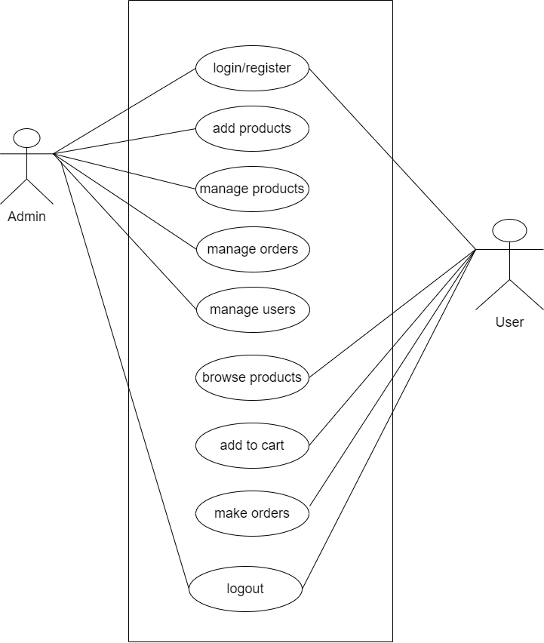

Figure 1: Use Case Diagram of Nursery Management System

In the above use case diagram, there are two modules where each of the modules have their specific functions.

**For Customers**:

* Customers can register and create an account.
* Secure login functionality for customer access.
* Customers can browse and search for products in the nursery inventory.
* Customers can add items to their cart and complete the purchase.

**For Admin**:

* Admin can securely log in and log out of the system.
* Admin can add, delete, and update nursery product details.
* Admin can monitor and manage customer information.
* Admin can handle and process customer orders, including tracking and fulfillment.

#### **ii. Non-functional Requirement**

The system has form-based interface for data entry and stores reports in formatted in a table and for user friendliness. The system has reasonable short time response. The system has good performance as response time is short. The system doesn’t crash in middle of process as it is reliable. System can be considered secure as only admin can view user’s information.

**a. Maintainability**

The Nursery Management System must have high level maintainability.

**b. Serviceability**

If issue arises in the Nursery Management System, then the project must be programmed in such a way that developer can service it again.

**c. Environmental**

The Nursery Management System must be working in latest operating system environment.

**d. Availability**

This is a web-based application, so it shall be available to anyone who can access it.

**e. Usability**

Nursery Management System must have a user-friendly interface.

**3.1.2. Feasibility Study**

#### **i. Technical Feasibility**

Since the project is design with PHP as code behind and MySQL as backend it is easy to install in the systems whenever needed. It is more efficient, easy and user friendly to understand by almost everyone. Huge amount of data can be handled efficiently using MySQL as backend. Hence this project has good technical feasibility*.*

#### **ii. Operational Feasibility**

The system is operationally feasible as it provides enough response and throughput time. Also, manpower to operate this system are easily available.

#### **iii. Economic Feasibility**

Economic feasibility is mainly concern with the cost incurred during their implementation of the software. Since the project is developed using PHP and MySQL which is more commonly available and free. After the completion of the system organization didn’t need to deploy any new hardware and software as the required software and hardware.

#### **iv. Schedule Feasibility**

The time required to complete the project is calculated and classified using the followingGanttchart:

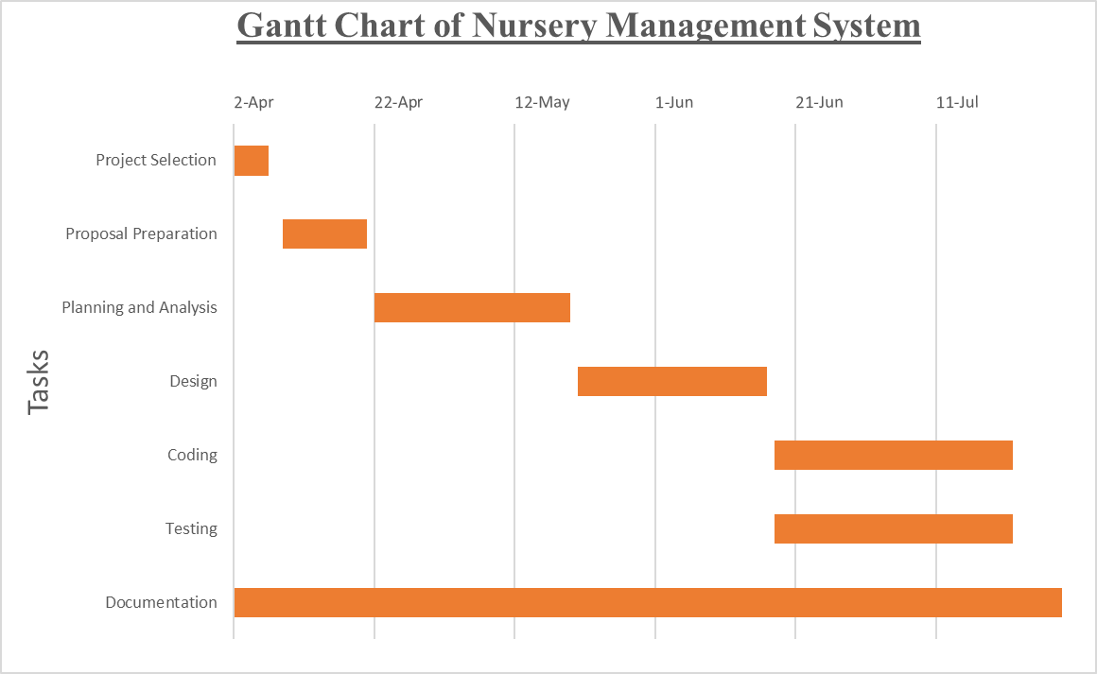

SFigure 2: Gantt Chart of Nursery Management System

**3.1.3. Data Modelling (ER-Diagram)**

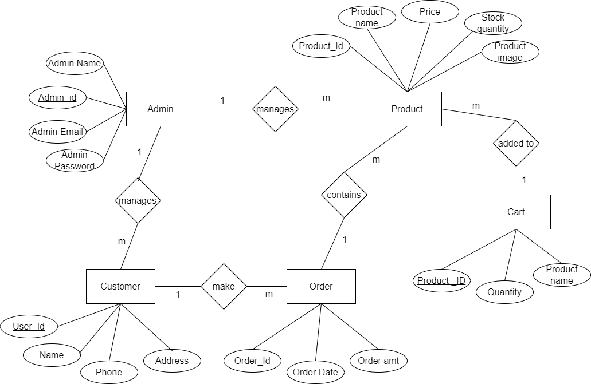

Figure 3: E-R Diagram of Nursery Management System

In the provided ER diagram for the Nursery Management System, the system encompasses five key entities: Admin, Customer, Product, Order, and Cart. Admins, responsible for overseeing nursery operations, are connected through a one-to-many relationship with customers, who are represented by their attributes such as name and contact details. Customers establish a one-to-many relationship with orders, reflecting their purchase activities over time. Products, comprising various plant species, share a one-to-many relationship with both carts and orders. Through these relationships, the Nursery Management System effectively manages plant inventory, customer interactions, and administrative control, enhancing overall nursery functionality.

**3.1.4. Process Modelling (DFD)**

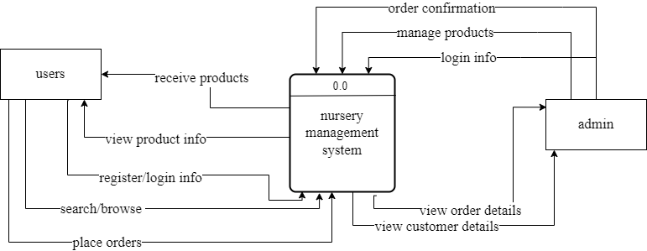

Figure 4: Context Diagram( Level 0 DFD) of Nursery Management System

The nursery management system context diagram identifies the flows of information between the system and external entities. Here the external entities are users who visit the nursery management system to view their information, users can login logout, browse and purchase products and admin can add products, manage products, and login logout to the system.

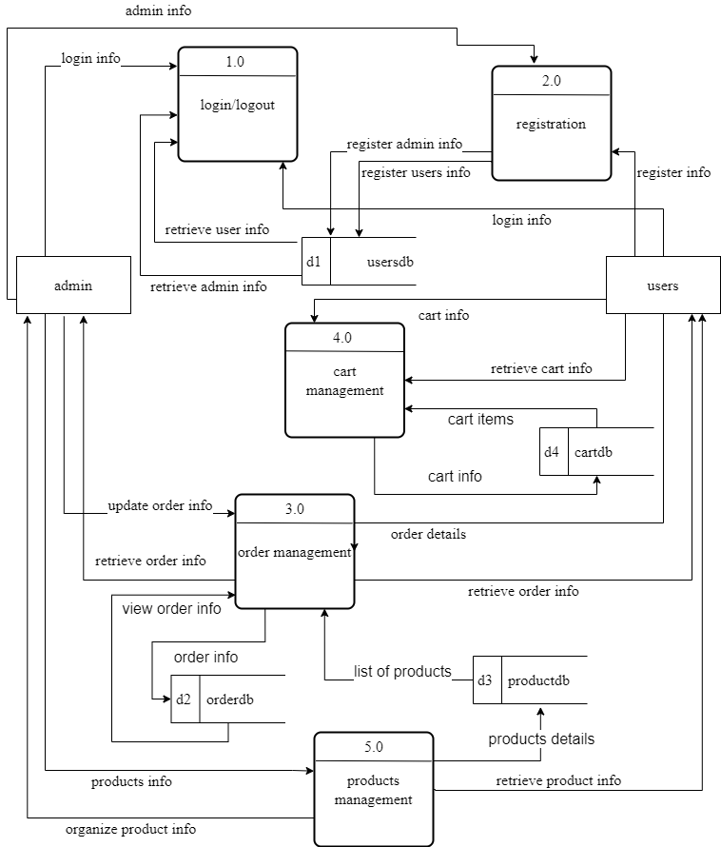

Figure 5: Level 1 DFD of Nursery Management System

In 1-level DFD, the context diagram is decomposed into multiple bubbles/processes. In this level, the main functions of the system were highlighted and breakdown the high-level process of context diagram into sub processes. The above level 0 DFD shows the detailed information about the proposed system. The above figure shows all the actions both users and admins can take.

## **3.2. System Design**

### **3.2.1. Architectural Design**

The system architecture consists of three major parts namely Graphical User Interface (GUI), front end and back end. The architecture displays the basic process flow. GUI is the interface visible to the user/customer. A GUI allows the use of icons or other visual indicators to interact with electronic devices; rather than using only text via the command line. It displays the different categories of grocery items, sign in, register etc. PHP & Xampp server are used as front-end technologies. When user clicks on the particular product, the query goes to the front end part. After that front end fetches the required data from the database i.e. Back end. The results are returned to front end and from there, to GUI for displaying. There is a database in the back end. It contains all the information regarding customers, products and vendors. Here, MySQL is used for this purpose. When user fires a particular query, the query is given to database and the corresponding result is segregated from large volume of information.

The following figure shows the architectural design of nursery management system

Figure 6: Architectural Design of Nursery Management System

### **3.2.2. Database Schema Design**

The database schema design for Nursery Management System showing all the relations along with their attributes and inter-relationship between the relations is shown below: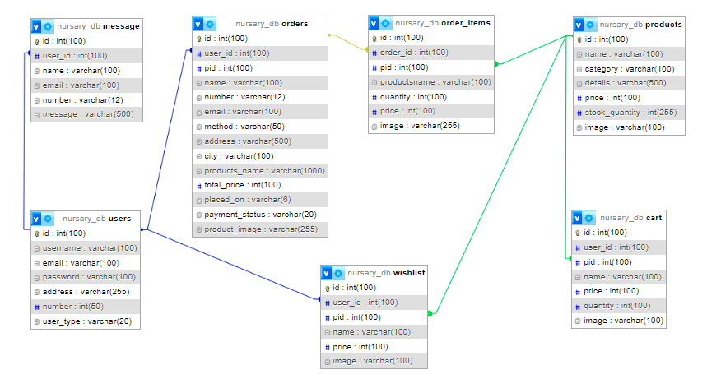

Figure 7: Database Schema Design of Nursery Management System

### **3.2.3. Interface Design**

The user interface of the application has been designed using Balsamiq Wireframes. It is a user interface design tool for creating wireframes (sometimes called mockups or low-fidelity prototypes). It can be used to generate digital sketches of an idea or concept for an application or website, facilitating discussion and understanding before any code is written.

Home Page:

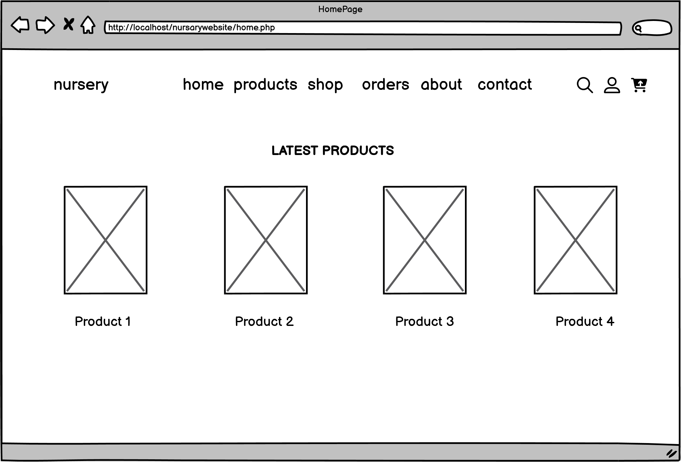

Figure 8: Home Page of nursery management system

Shop Page:

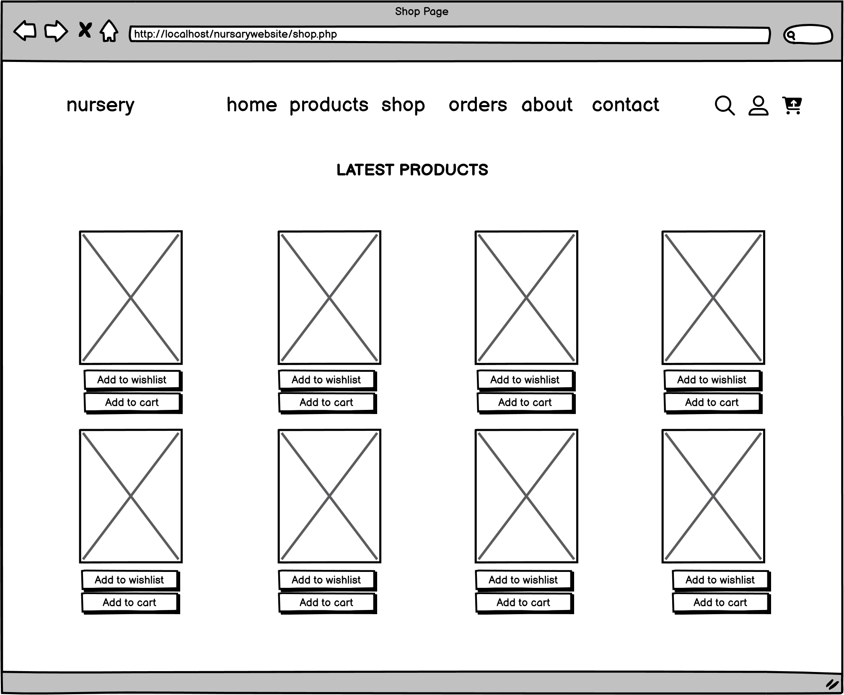

Figure 9: Shop Page of nursery management system

Login Page:

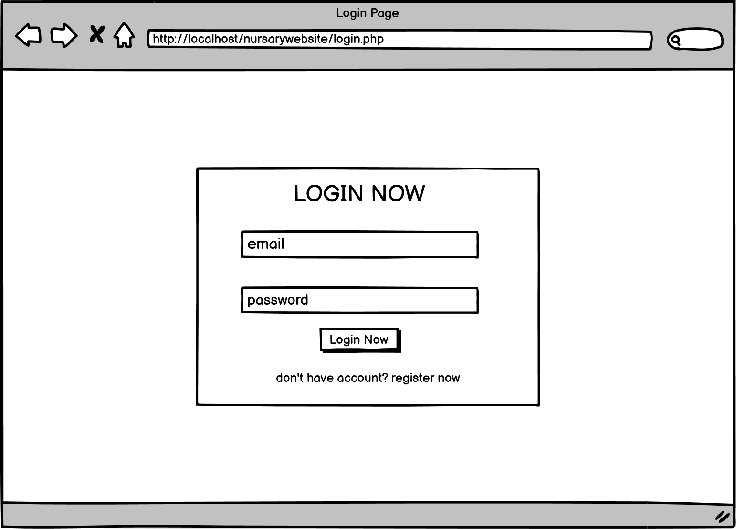

Figure 10: Login form

Register Page:

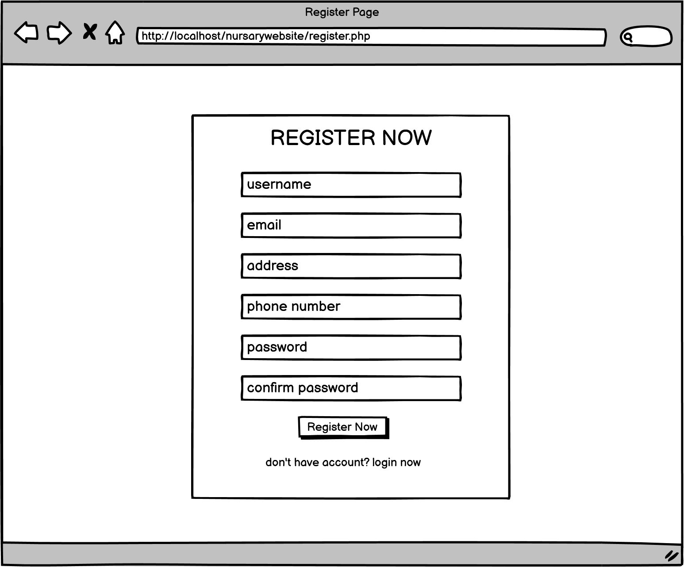

Figure 11: Register form

Cart Page:

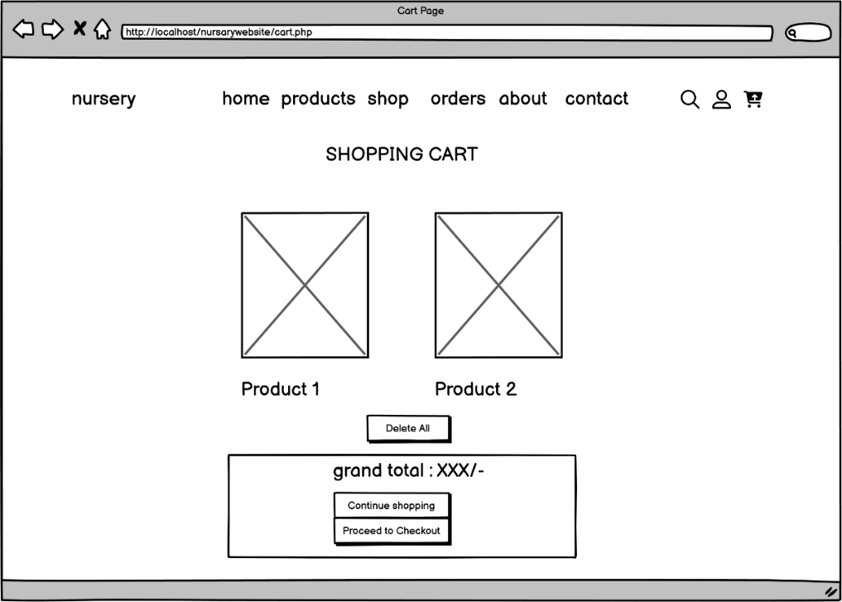

Figure 12: Cart Page of Nursery Management System

Admin Panel:

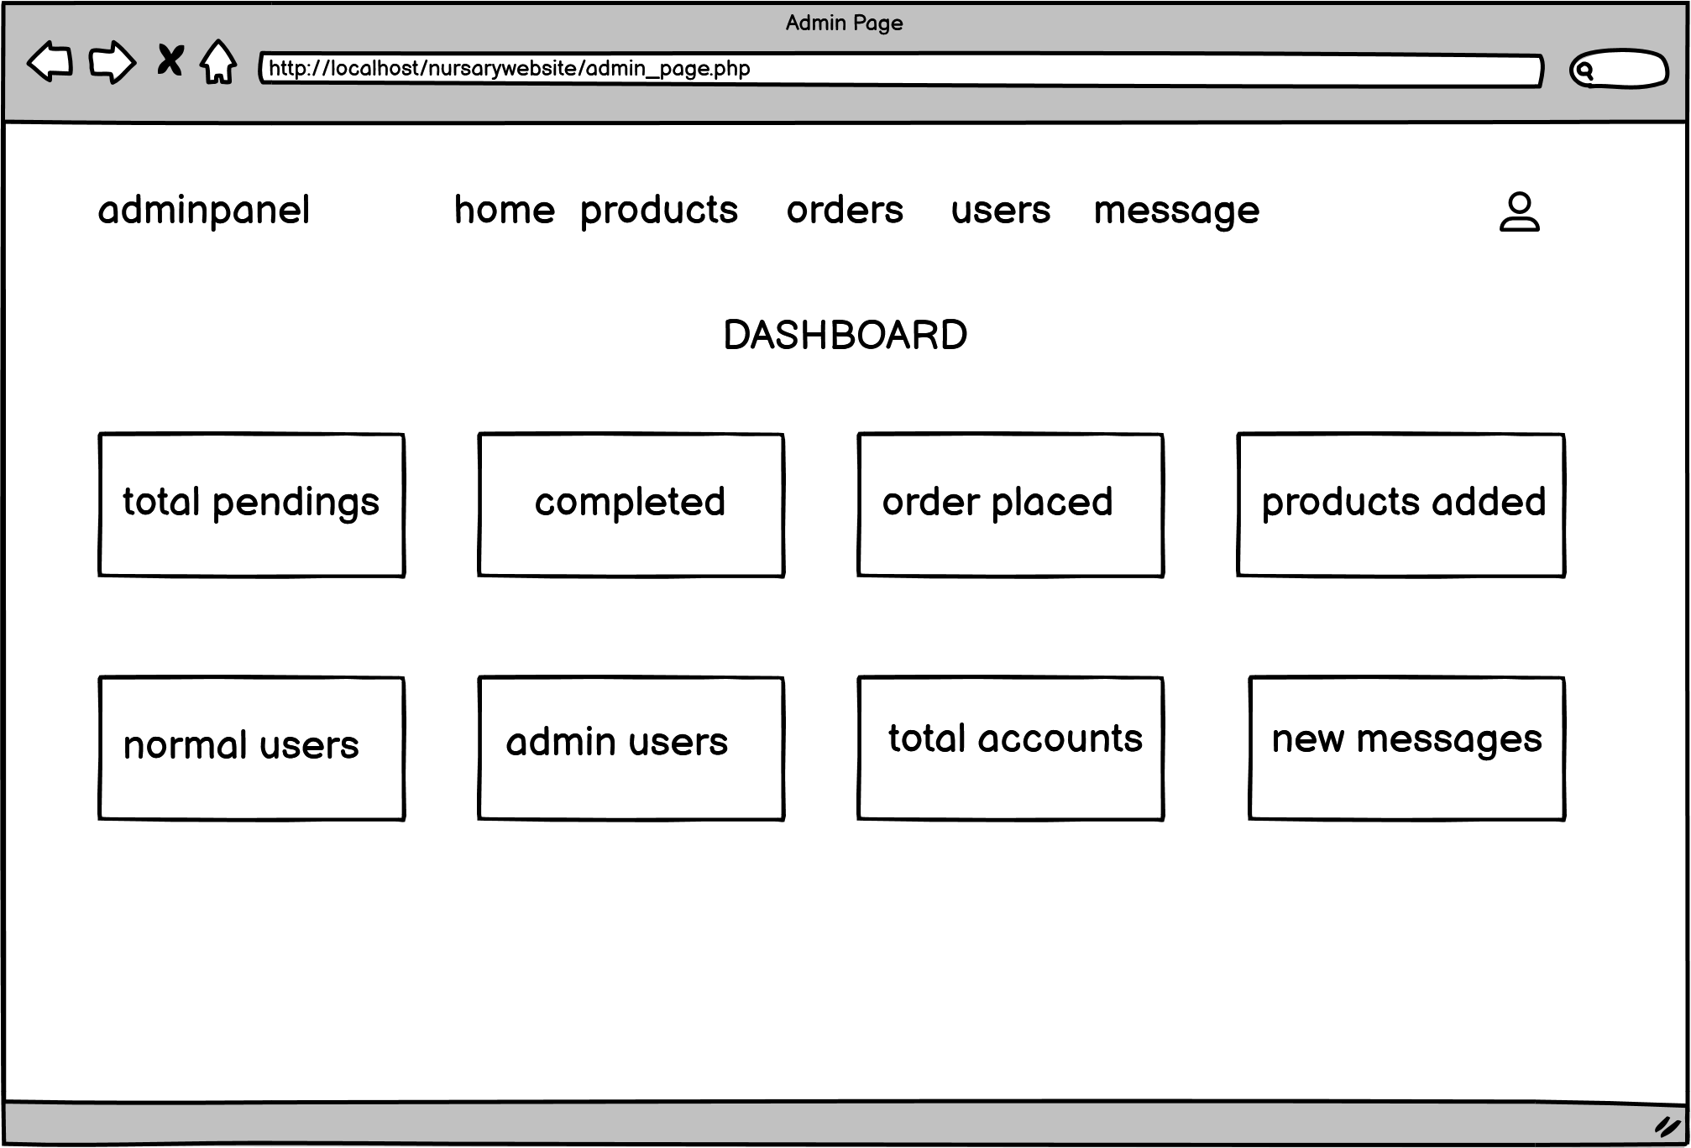

Figure 13: Admin Dashboard

Admin Add Product:

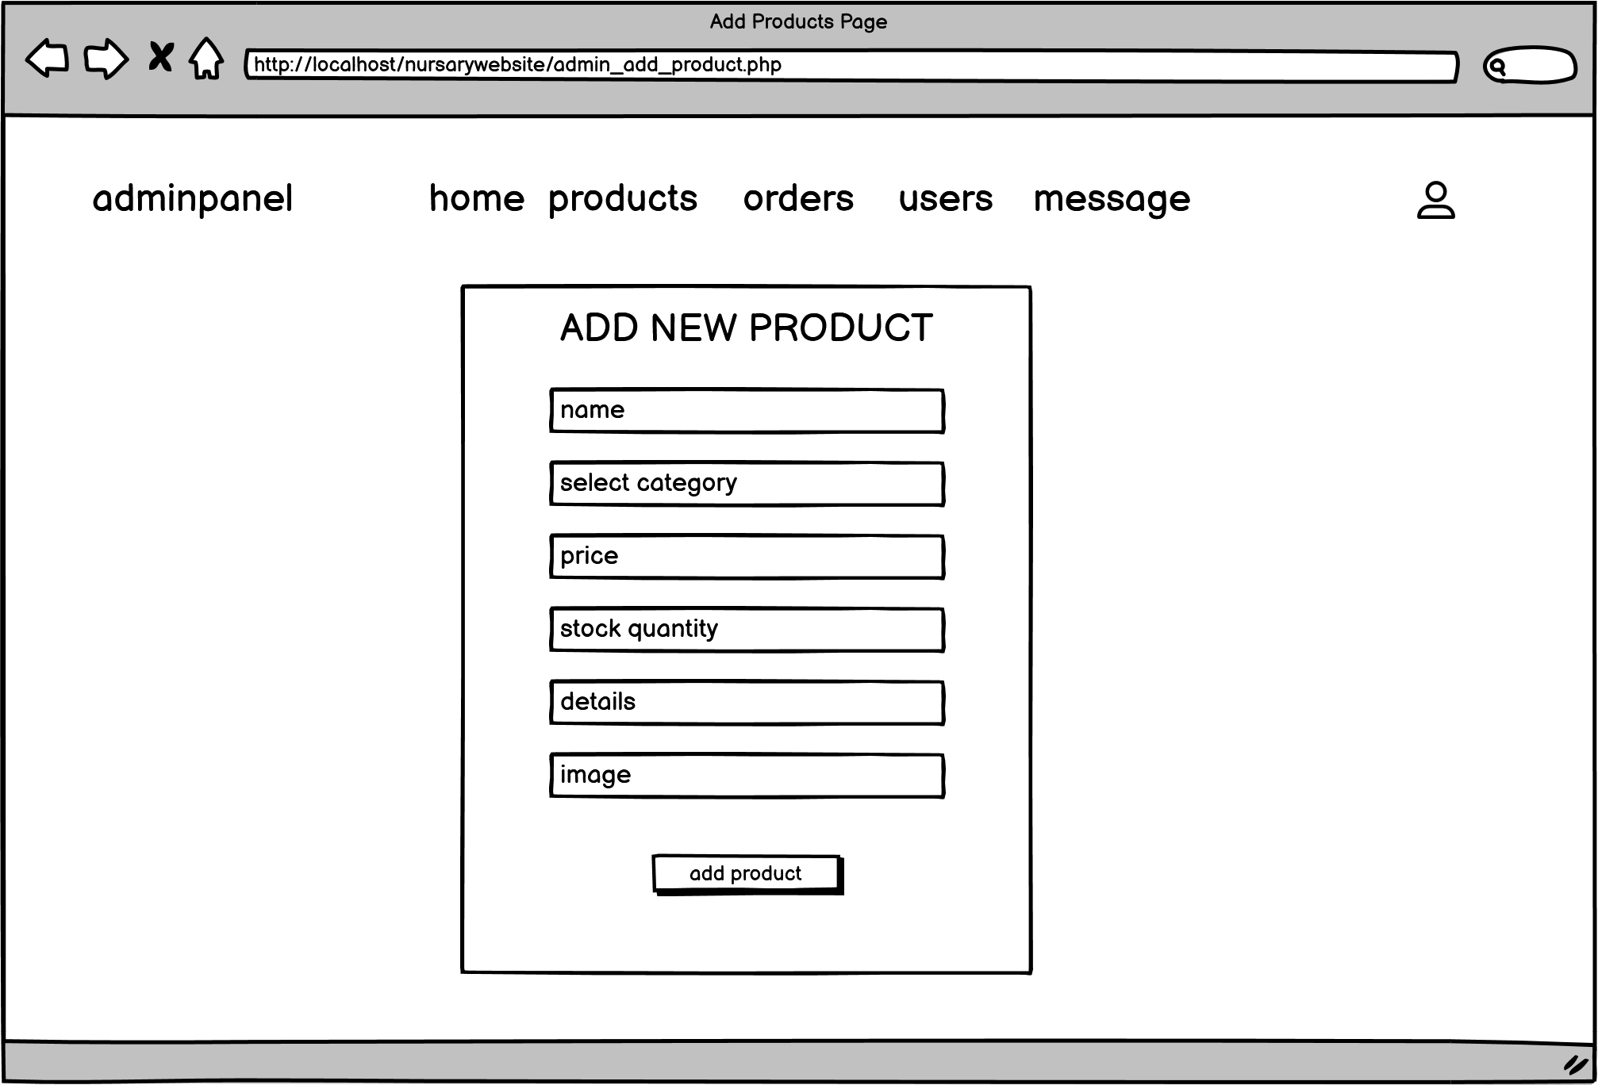

Figure 14: Admin add product form

Admin (User Account details) Panel:

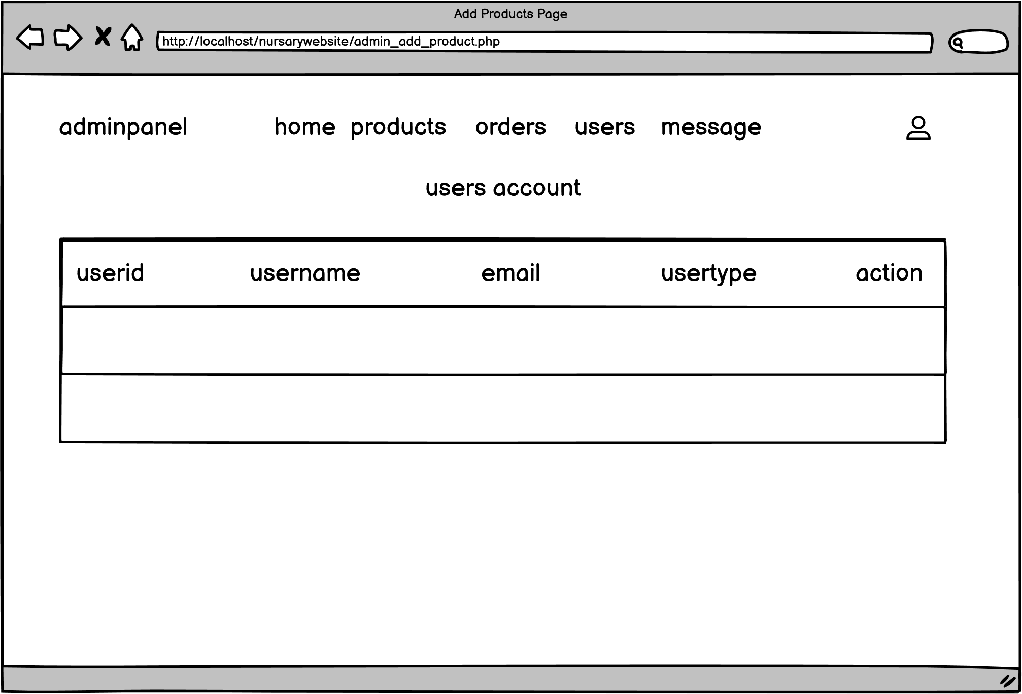

Figure 15: User account page in admin page

**3.2.4. Physical DFD**



Figure 16: Physical DFD of Nursery Management System

This Nursery Management System facilitates the exchange of information among various entities involved. When a user provides login credentials to the system, the credentials are verified from the users table in the database. Similarly, when a user registers an account, the new information is updated in the same table.

Upon logging in, administrators' information is verified from the users table in the database, while for regular users, their information is verified from the user table. When users browse and search for products, the system retrieves the product information from the products table.

When users add items to their shopping cart, the cart's contents are updated in the cart table. Upon checkout, the system stores the order information in the order table. Admins can manage products by adding, editing, or deleting entries in the product table.

When users view their order history, the system retrieves the data from the order table. Additionally, when users submit feedback, the feedback data is stored in the message table.

In summary, the Nursery Management System relies on database interactions to manage user accounts, products, shopping carts, orders, feedback, and administrative tasks. The various tables within the database store and retrieve relevant information to ensure seamless functioning of the system.

# **CHAPTER 4: IMPLEMENTATION AND TESTING**

## **4.1. Implementation**

Implementation is the process through which a decision or plan is translated into effect. During implementation, coding is commenced in accordance with the established requirements.

### **Tools Used**

**Diagram Tool:**

“Draw.io” is used to make all the system designs required for this project. It is a proprietary software for making diagram and charts. The software lets us choose from an automatic layout function or create a custom layout. The drag and drop feature make it simple to create a great looking diagram or chart.

**Web Application Development Tools:**

Various different tools are used to design the web page for this project.

1. **HTML:**

HTML is a markup language which is used for creating web pages and which defines the structure of web pages. HTML has been employed for the front end, and it stands as one of the fundamental building blocks for every website.

1. **CSS:**

CSS is the language for describing the presentation of web pages, including colors, layout and fonts. It is a simple design language intended to simplify the process of making web pages presentable.

1. **JavaScript**

JS (JavaScript) is a lightweight, interpreted programming language. It is designed for creating network-centric applications. JavaScript is very easy to implement because it is integrated with HTML. It is open and cross-platform.

1. **PHP:**

PHP is an open-source general-purpose scripting language that is especially suited for web development and can be embedded into HTML. It is a scripting language used to create dynamic websites. A dynamic page has been created with the aid of PHP.

1. **MySQL:**

MySQL is an open-source relational database management system. It is based on the structure query language, which is used for adding, removing and modifying information in the database. Different types of commands like add, drop, insert, and update can be performed with the assistance of MySQL.

1. **Visual Studio Code**

Visual studio code is a source-code editor which includes features like debugging, syntax highlighting, intelligent code completion, etc. It was made by Microsoft and can run on different types of operating systems like Windows, Linux and Mac OS. Different programming language are readily available thus making the coding process faster and hassle free.

1. **Apache**

Apache is the actual web server application that processes and delivers web content to a computer. Apache is the most popular web server online, powering nearly 54% of all websites.

### **Implementation Details of Modules**

**i. Registration Module**

The registration module allows users to input necessary and valid information on the registration form, enabling them to access the system. Once the provided information is verified, users can successfully register and gain access to the nursery management system's dashboard.

**ii. Login Module**

The login module grants access to the nursery management system for various users, including customers, administrators, and staff. Customers enter their registered details, while administrators and staff provide valid credentials. Upon successful verification, users can log in to their respective accounts and access the system's functionalities.

**iii. Logout Module**

The logout module provides users with a secure way to end their sessions and log out from the nursery management system. When users initiate the logout process, the system terminates their active session, ensuring that their access to system features and data is revoked.

**iv. Add Product Module**

Through this module, administrators can add new products to the system by entering valid product information. The module facilitates the expansion of the product inventory, enabling a wider range of offerings in the nursery management system.

**v. Delete Product Module**

Admin users utilize this module to remove products from the system that are no longer available or relevant. This helps in maintaining an accurate and up-to-date product catalog within the nursery management system.

**vi. Browse and Search Module**

The browse and search module allows customers to explore and search for various nursery products based on different criteria such as plant type, price, and availability. This module enhances the customer's browsing experience and helps them find desired products efficiently.

**vii. Cart Management Module**

Customers manage their selected items using the cart management module. They can add products to their cart, view the cart's contents, and proceed with the checkout process, streamlining the purchasing process within the nursery management system.

**viii. Order Management Module**

This module assists administrators in managing customer orders. Admins can view, track, and process orders, including order status, payment details, and order history. The module ensures efficient handling of customer orders.

**x. Contact Us Module**

The contact us module enables customers to reach out to the nursery management system's support team for inquiries or assistance. Customers can submit their queries through this module, fostering communication and providing customer support.

## **4.2. Testing**

Once source code has been generated, software must be tested to correct as many errors as possible before delivery to customer. Our goal is to design a series of test cases that have a high likelihood of finding errors. Following testing techniques are well known and the same strategy is adopted during this project testing.

### **Test Cases for Unit Testing**

Each view/module of the application are tested individually. As the modules were built up testing was carried out simultaneously, tracking out each and every kind of input and checking the corresponding output until module is working correctly.

**Table 1: Test Case of Login Form**

|  |  |  |  |  |  |
| --- | --- | --- | --- | --- | --- |
| Project Name: Nursery Management System | | | | | |
| Test Case | | | | | |
| Test Case ID: TC_1 | | | | Test Designed by: Your Name | |
| Test Priority (Low/Medium/High): High | | | | Test Designed Date: 2023-06-05 | |
| Module Name: Login Form | | | | Test Executed by: Your Name | |
| Test title: Verify login validation | | | | Test Execution date: 2023-06-12 | |
| Description: Test the Nursery Management System’s login page | | | | | |
| Pre-condition: User has valid username and password, also invalid username and password are entered | | | | | |
| Dependencies: | | | | | |
| Step | Test Scenario | Test Steps | Test Data | Expected Result | Pass/ Fail |
| 1 | Navigate to login page |  | Login page should open | The user is navigated to the login page of the  system | Pass |
| 2 | Input valid  email | Username: [user1@gmail.com](mailto:user1@gmail.com) | The username can be entered | As expected | Pass |
| 3 | Input valid password | Password: 1234 | The password can be entered | As expected | Pass |
| 4 | Click on  Login  button |  | User should be able to login into the system | As expected | Pass |
| 5 | Input invalid  username and  password | Enter invalid username or password. | An error messages  “Invalid  Email or Password...” Must be displayed. | As expected ,an error message “Invalid Username or Password. Please Try again.” Is displayed. | Pass |
| Post-conditions: Users are validated with database and successfully logged into Nursery Management Systems, the invalid username or password failed to login. | | | | | |

**Table 2: Test Case of Registration Form**

|  |  |  |  |  |  |
| --- | --- | --- | --- | --- | --- |
| Project Name: Nursery Management System | | | | | |
| Test Case | | | | | |
| Test Case ID: TC_2 | | | | Test Designed by: Your Name | |
| Test Priority (Low/Medium/High): High | | | | Test Designed Date: 2023-06-05 | |
| Module Name: Register Form | | | | Test Executed by: Your Name | |
| Test title: Register new users into the system and validate the form | | | | Test Execution date: 2023-06-12 | |
| Description: Test the Nursery Management System’s login page | | | | | |
| Pre-condition: User should have all the necessary details | | | | | |
| Dependencies: | | | | | |
| Step | Test Scenario | Test Data | Expected Result | Actual result | Pass/Fail |
| 1 | Navigate to registration page |  | Registration page should open | The user is navigated to the registration page of the  system | Pass |
| 2 | Provide all the required information | Username = user1  Email =  [user1@gmail.com](mailto:user1@gmail.com)  Address =  Kathmandu  Phonenumber =  9800000000  Password = 1234  Confirm password  = 1234 | The information  should be entered | As expected the information is entered | Pass |
| 3 | Click on  the register  button |  | The user should be  entered into the system | As expected the user is registered | Pass |
| 4 | Registration  Form  Password validation | Input unmatched password | Display alert  Message “Confirm Password does not match.” | Display alert message “Confirm password doesn’t match Password.  Please try again.” | Pass |
| 5 | Registration Form user name  validation | Invalid username | If same  username display message ‘’Sorry, Username already taken’’ else register | Creates an ID and enters the system | Fail |
| Post-conditions: Users are validated with database and successfully logged into Nursery Management Systems. | | | | | |

**Table 3: Test Case for User's Functions**

|  |  |  |  |  |  |
| --- | --- | --- | --- | --- | --- |
| Project Name: Nursery Management System | | | | | |
| Test Case | | | | | |
| Test Case ID: TC_3 | | | Test Designed by: Your Name | | |
| Test Priority (Low/Medium/High): High | | | Test Designed Date: 2023-06-05 | | |
| Module Name: User's Functions | | | Test Executed by: Your Name | | |
| Test title: Test case for User's Functions | | | Test Execution date: 2023-06-12 | | |
| Description: Test the Nursery Management System's View Products | | | | | |
| Pre-condition: | | | | | |
| Dependencies: | | | | | |
| Test case ID | Test Scenario | Test Steps | Test Data | Expected Result | Pass/ Fail |
| 1 | View Products | Go to different  Products (plants,  seeds, fertilizers) | Click at the  products. | User can view  products in  other page. | Pass |
| 2 | Add to Cart | Click on add to cart button | Clicked on add to cart button | Items is added to cart | Pass |
| 3 | Remove from cart | Click on delete all button to delete all item | Clicked on delete all button | Items deleted from cart | Pass |
| 4 | Add to wish list | Click on add to wish list button | Clicked on add to wish list button | Items is added to wish list | Pass |
| 5 | Placed the order | After filling checking out form and click on order now button | Filled the form and clicked on the order now button | Order is placed as expected | Pass |

**Table 4: Test Case for Admin's Functions**

|  |  |  |  |  |  |
| --- | --- | --- | --- | --- | --- |
| Project Name: Nursery Management System | | | | | |
| Test Case | | | | | |
| Test Case ID: TC_4 | | | | Test Designed by: Your Name | |
| Test Priority: High | | | | Test designed date: 2023-06-13 | |
| Module Name: Admin’s function | | | | Test Executed by: Your Name | |
| Test Title: Add/ Update/ Delete products, manage the orders and users | | | | Test Execution date: 2023-08-3 | |
| Description: Test if the admin can manage student’s information. | | | | | |
| Pre-condition: Student’s information should be available in the system. | | | | | |
| Dependencies: | | | | | |
| Step | Test Steps | Test Data | Expected Result | Actual result | Pass/Fail | |
| 1 | Input valid admins info | Email=admim1@gmail.com Password=  1234 | Admin’s dashboard should open | As expected, the admin dashboard is opened | Pass | |
| 2 | Add the products | Product name = rose  Category = plants  Price = 1500  Quantity = 15  Products details=  Upload image= rose.jpg | The product should be added | As expected, the products is added in the database | Pass | |
| 3 | Delete the products |  | The product  is deleted from the  database | As expected, the  product is  deleted as expected | Pass | |
| 4 | Update the products | Enter the update form with the updated data | The product is updated in the database | As expected, the product is updated. | Pass | |
| 5 | Confirm the user orders | Select the order status and confirm the order | The order should be confirmed | As expected, the order status is updated | Pass | |

### **Test Cases for System Testing**

System testing is the process of testing how the various components of an application interact together in full, integrated system or application. It verifies that an application performs tasks as designed.

**Table 5: Testing Whole System**

|  |  |  |  |  |  |  |  |
| --- | --- | --- | --- | --- | --- | --- | --- |
| SN | Test Case id | Test Case Name | Test Case Descript ion | Step | Expected Result | Actual Result | Test Case status Pass/  Fail |
| 01. | TC 5 | Security Testing | Checking Security to access system | Login with your registered username and  password | Successful Login Directed to User dashboard. | Successful Login Directed to User dashboard. | Pass |
| 02. | TC  6 | Security Testing | Checking Security to access system | Try Login with unauthorized email and password | An error message “Invalid credentials” must be displayed. | An error message “Invalid credentials” displayed. | Pass |
| 03. | TC  7 | Usability Testing | Eliminate Duplicate email data on registration | User Registration with already available email | Message displayed “Email already exists.” | Message displayed “Email already exists.” | Pass |
| 04 | TC  8 | Usability Testing | User ordering products | User ordering products | Ordered successfully. | Ordered  Successfully. | Pass |
| 05 | TC  9 | Usability Testing | Adding items to cart and wish list | Adding items to cart and wish list | Items added successfully | Items added successfully | Pass |
| 06. | TC 10 | Load Testing | Testing Load of system | For demo test 5 users  were added | System performs well | System performs well | Pass |
| 07. | TC 11 | Regression Testing | Testing new bugs during the development and changes | Development and changes on code. | Bugs found and solved | Bugs found and solved | Pass |
| 08. | TC 12 | Migration testing | Migrating System to another PC | Migrating System to another PC | System works successfully | System works successfully | Pass |

# **CHAPTER 5: CONCLUSION AND FUTURE RECOMMENDATIONS**

## **5.1 Lesson Learnt/ Outcome**

Upon the conclusion of our project titled "Nursery Management System," our understanding of project development and management has been enriched with a multitude of lessons that have been fortified. Throughout the course of this endeavor, the intricate workings of designing a functional system were not only grasped but also abilities in teamwork and efficient resource management were honed.

The utilization of modern technologies, such as HTML, CSS, PHP, and MySQL, to create a user-friendly and efficient platform, is one of the key takeaways from this project. Particularly, the utilization of these technologies in the context of nursery management was explored, and in doing so, the skillset and problem-solving capabilities were broadened.

A pivotal role was played by collaboration in the successful execution of this project. As a team, the importance of effective communication, division of tasks, and mutual support was discovered. These experiences have fortified the ability to navigate collaborative projects in the future with heightened efficiency and cohesion.

Furthermore, confidence to embark on more ambitious ventures has been kindled by the Nursery Management System project. Armed with the knowledge gained from this endeavor, the development of web applications that cater to diverse needs while implementing advanced features and functionalities is looked forward to.

In summation, the Nursery Management System project has been a learning journey encompassing technology integration, teamwork enhancement, and effective project management. As progress is made, these lessons are carried forward, ready to tackle new challenges with innovation, dedication, and a commitment to delivering impactful solutions in the realm of nursery management and beyond.

## **5.2 Conclusion**

In conclusion, the Nursery Management System demonstrates remarkable flexibility and user-friendliness. The majority of the stipulated requirements have been successfully met, attaining a high level of satisfaction. Any remaining requirements can be swiftly addressed through a brief extension of the project timeline. The project has been developed using HTML, CSS, PHP, and MySQL, ensuring its compatibility for execution on various systems. Rigorous testing was conducted, subjecting the website to maximum server load, resulting in rapid and efficient performance. This nursery management system provides an extensive platform to cater to the diverse needs of plant enthusiasts, offering a wide array of choices and selections. It empowers users to enhance their living spaces, gardens, and surroundings with a rich assortment of plants and gardening essentials, fostering beautiful and vibrant landscapes.

**5.3 Future Recommendations**

There are few improvement and addition that can be added to the system like:

1. Payment gateway can be added,
2. Provide the billing details,
3. More responsiveness website,
4. Multilingual to this site can be added,
5. Payment Options Must Be Plentiful - Some customers pay with credit cards, debit cards, while others use esewa, fonepay, etc. Make sure the options are all there.

# **REFERENCES**

|  |  |  |
| --- | --- | --- |
| [1] |  | R. S. Pressman, Software Engineering: A Practitioner's approach".6th Edition, McGraw Hill International edition, 2005. |
| [2] |  | S. R and L. S.T. Maurya, "Project Report on "AGTRADE: AGRICULTURE PRODUCT TRADING SYSTEM"". |
| [3] |  | “IJRASET: International Journal & Research Paper Publisher.” https://www.ijraset.com/ |
| [4] |  | “(PDF) Useful Mobile Applications for Nursery and Field Personnel.” https://www.researchgate.net/publication/322276443_Useful_Mobile_Applications_for_Nursery_and_Field_Personnel |
| [5] |  | P. P. Ray, "Internet of things for smart agriculture: Technologies, practices and future direction". |
| [6] |  | O. Azmi, Design Development and Implementation of Agriculture Online Service System. 2001. |
| [7] |  | "e-nursery," [Online]. Available: https://www.enurserynepal.com/. |
| [8] |  | "Om Nursery Nepal," [Online]. Available: https://omnurserynepal.com/. |
| [9] |  | "KUMARI FLORA," [Online]. Available: https://kumariflora.com/. |

# **APPENDICES**

Home Page:

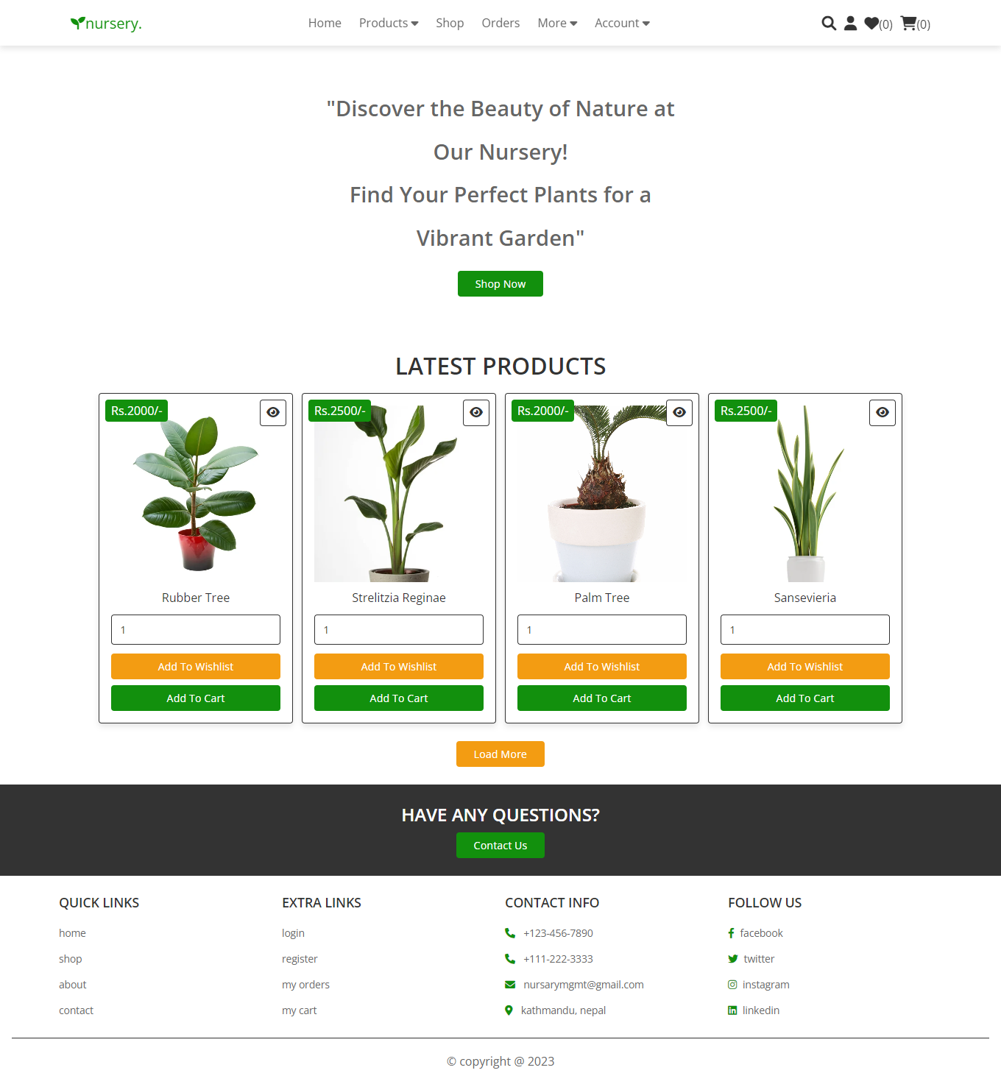

Shop Page:

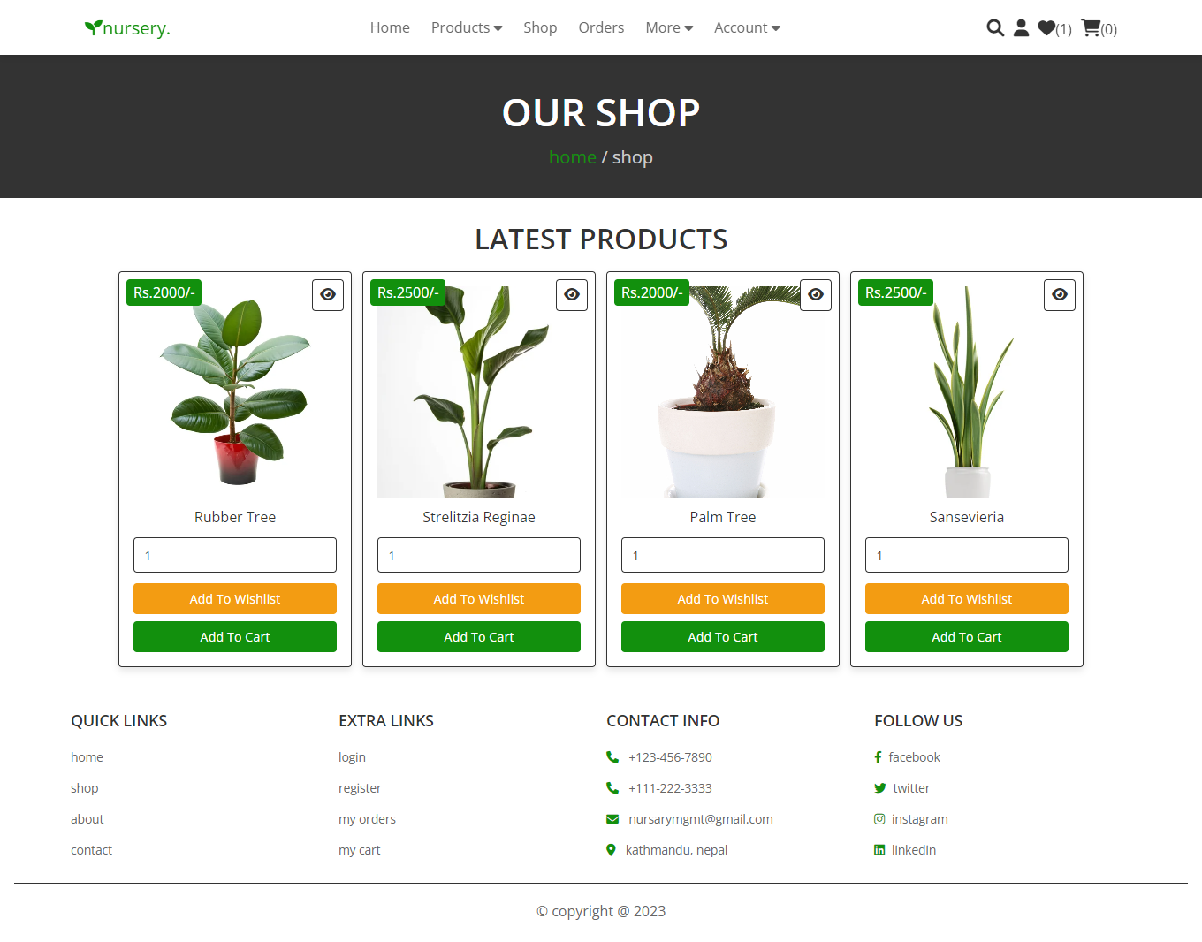

Login Page:

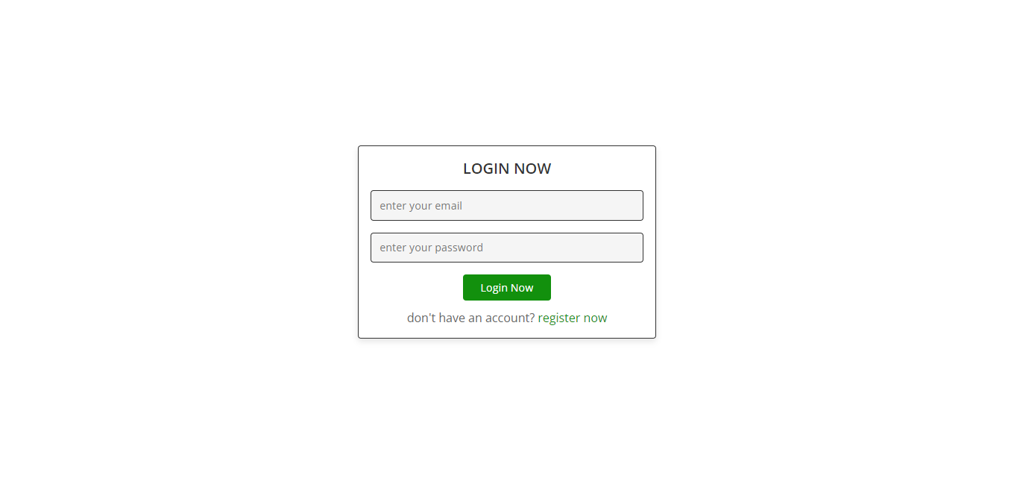

Register Page:

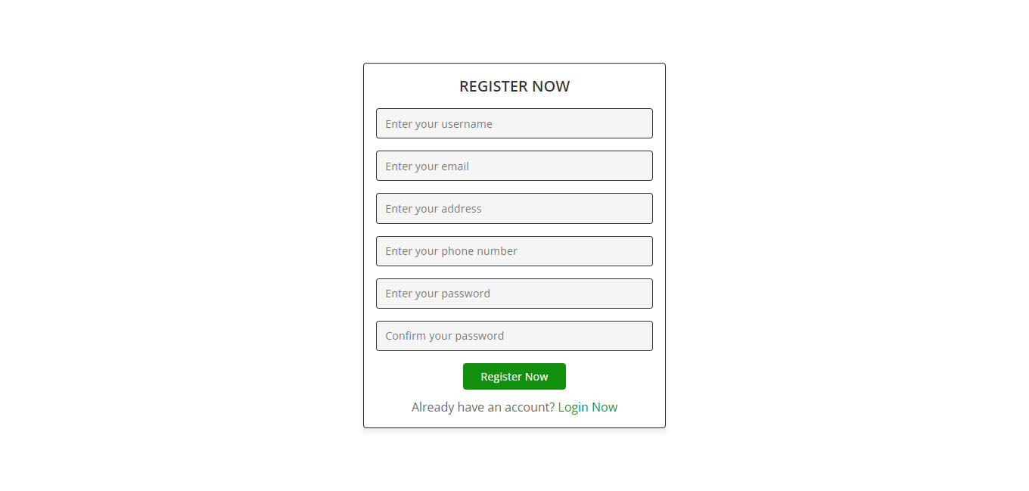

Cart Page:

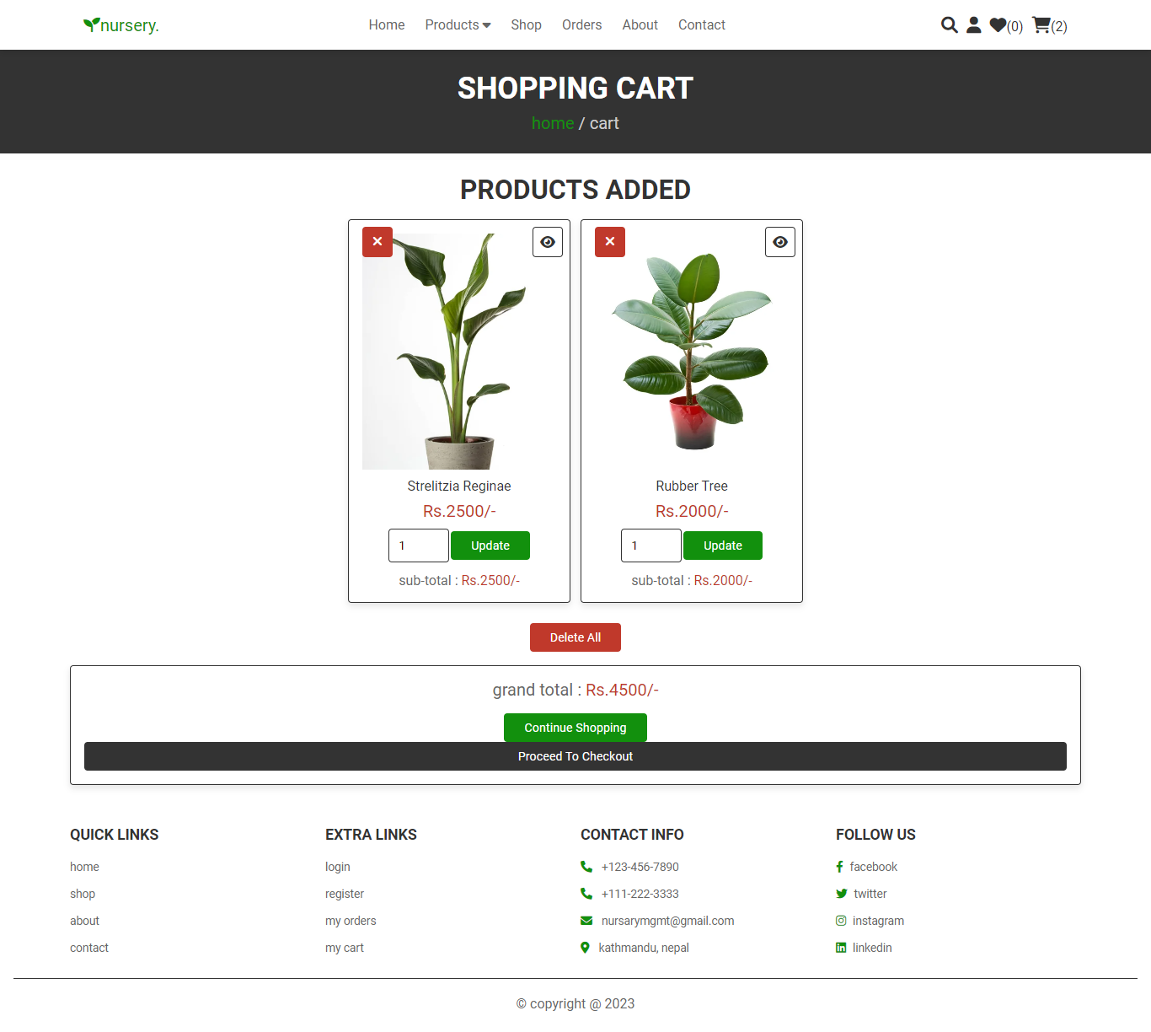

Admin Panel:

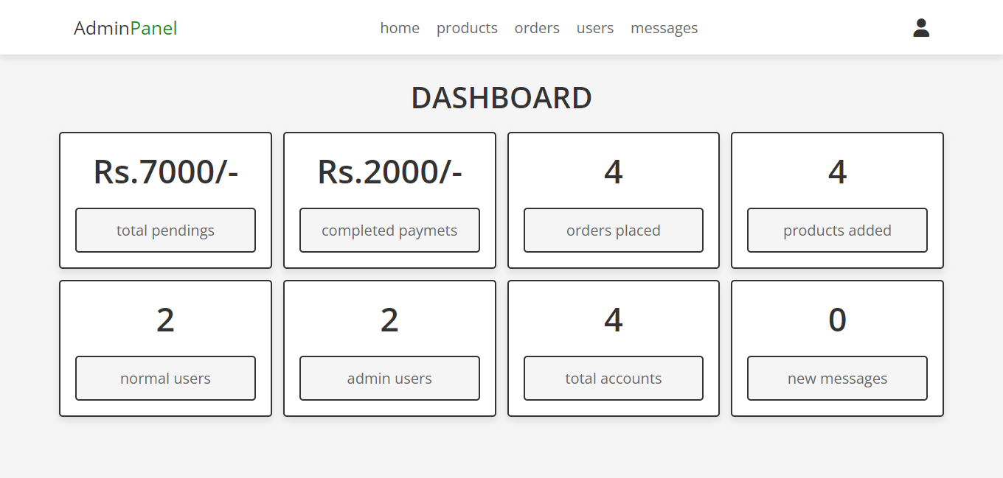

Admin Add Product:

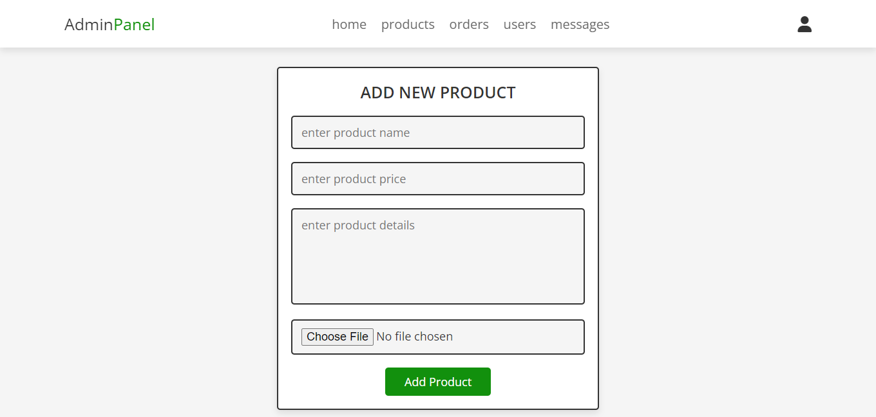

Admin (User Account details) Panel:

